NEURON STACKING
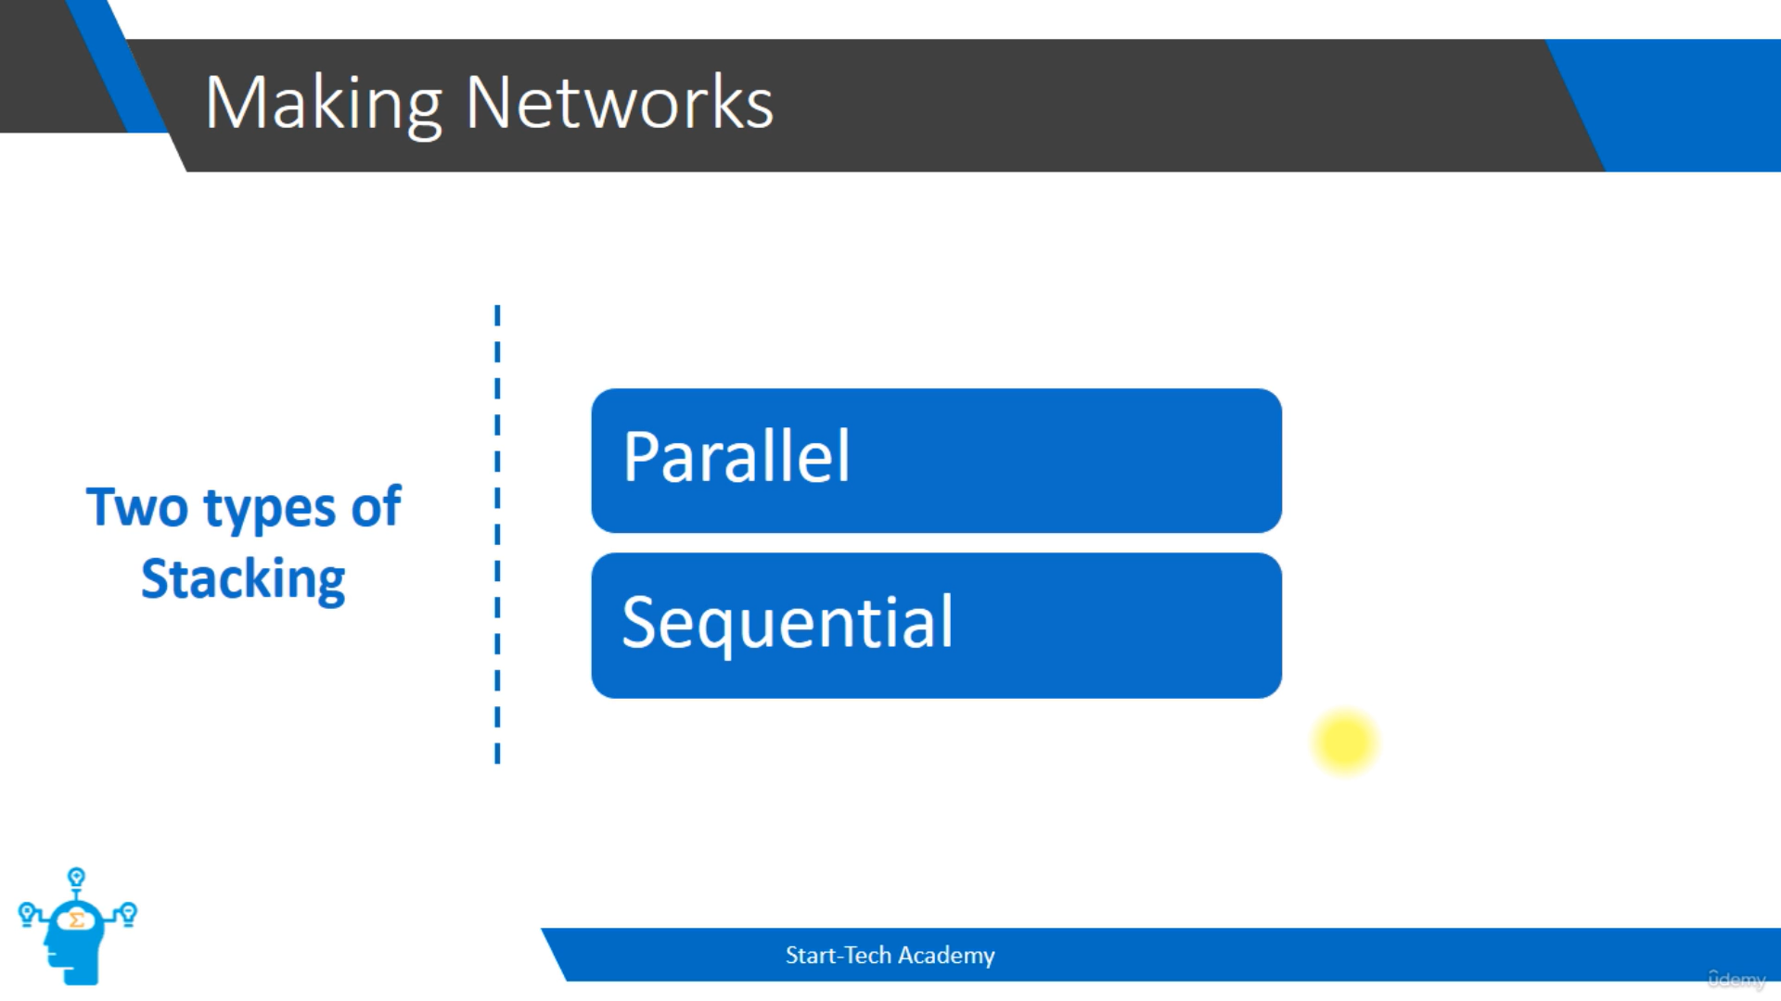
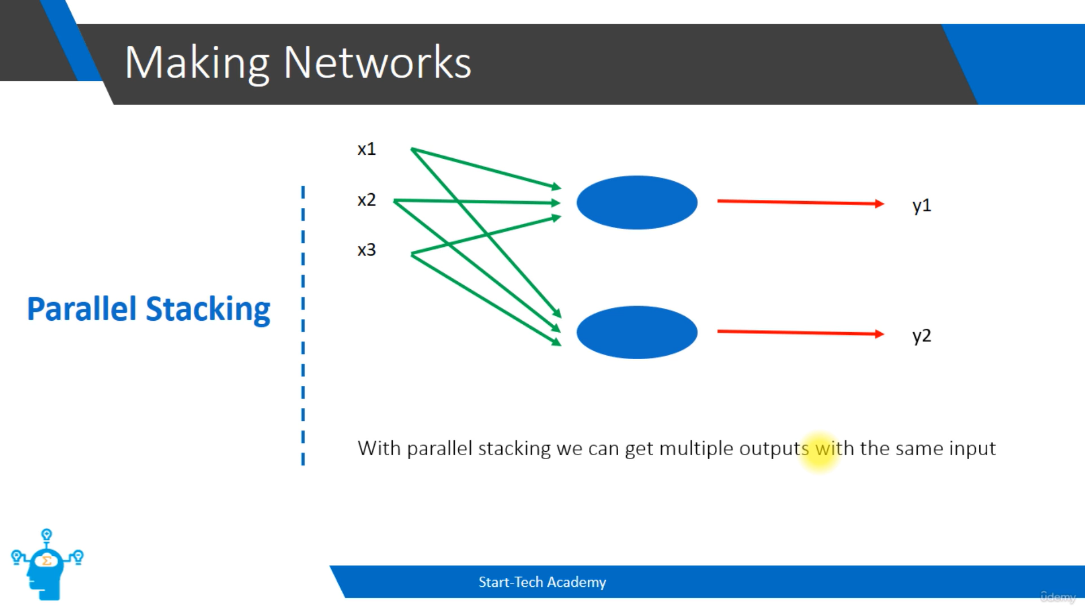
It also tells that, we can get multiple outputs as well with the same input.
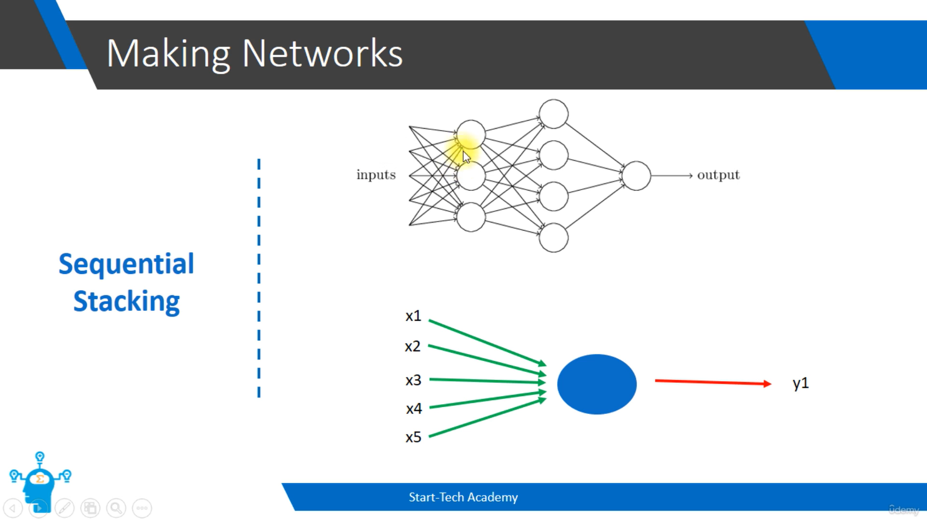
Here there are 5 inputs coordinate with 3 perceptron and the output from that will became the inputs of the next 5 perceptron and the output will go to another perceptron as input and finally gives the output. This process is called Sequential stacking.
Why it is necessary?
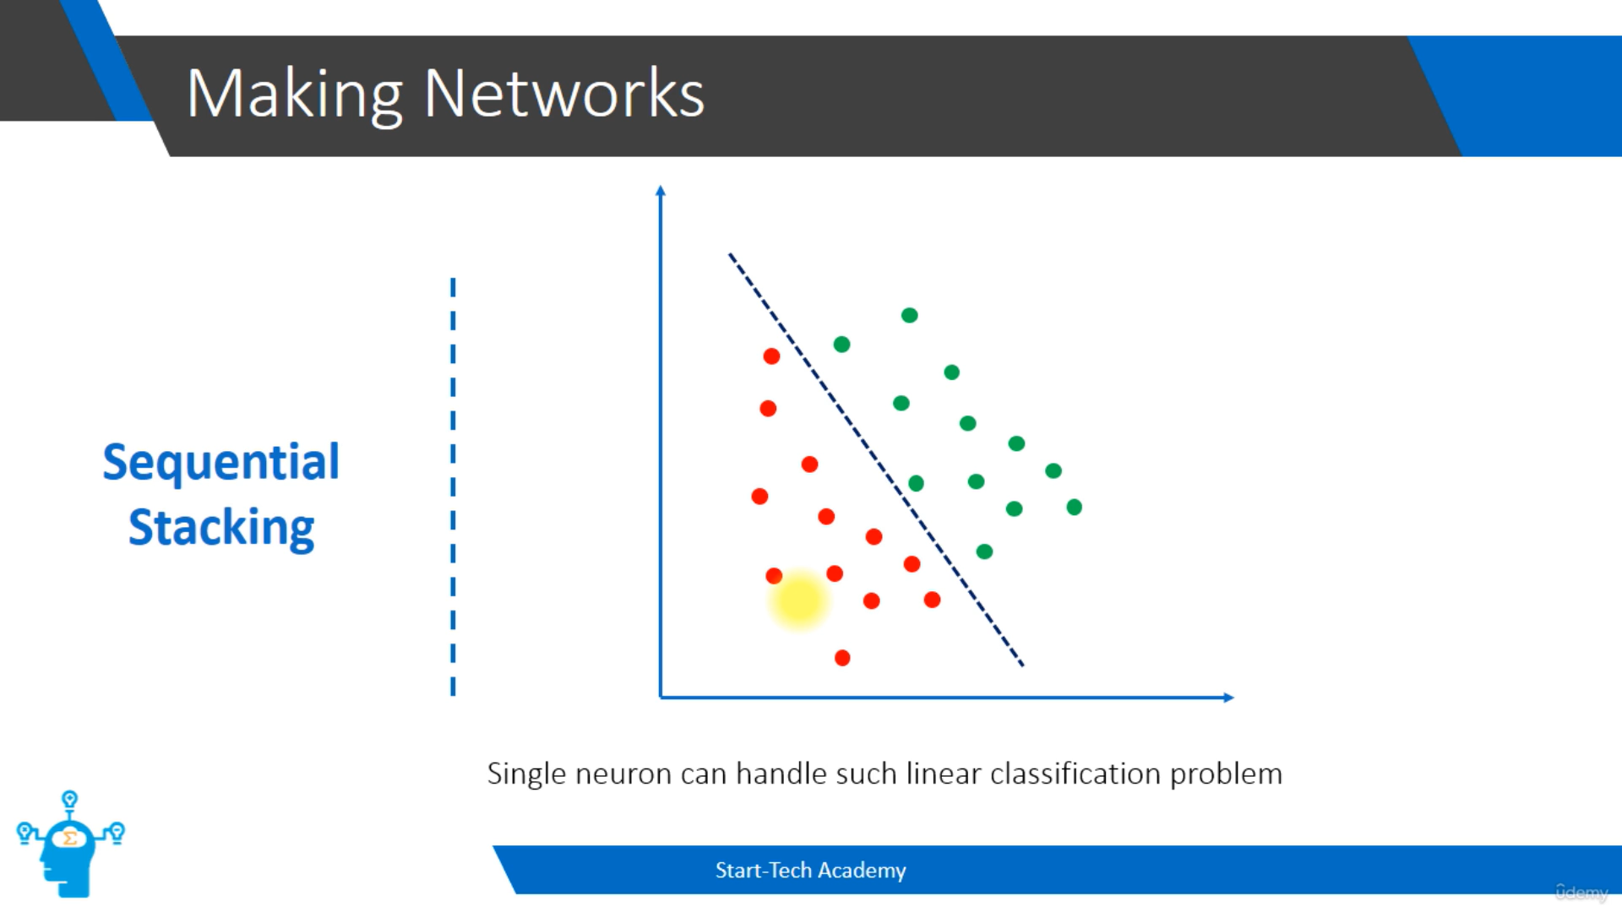
The above problem doesn’t need sequential stacking because the problem is simple not complex.
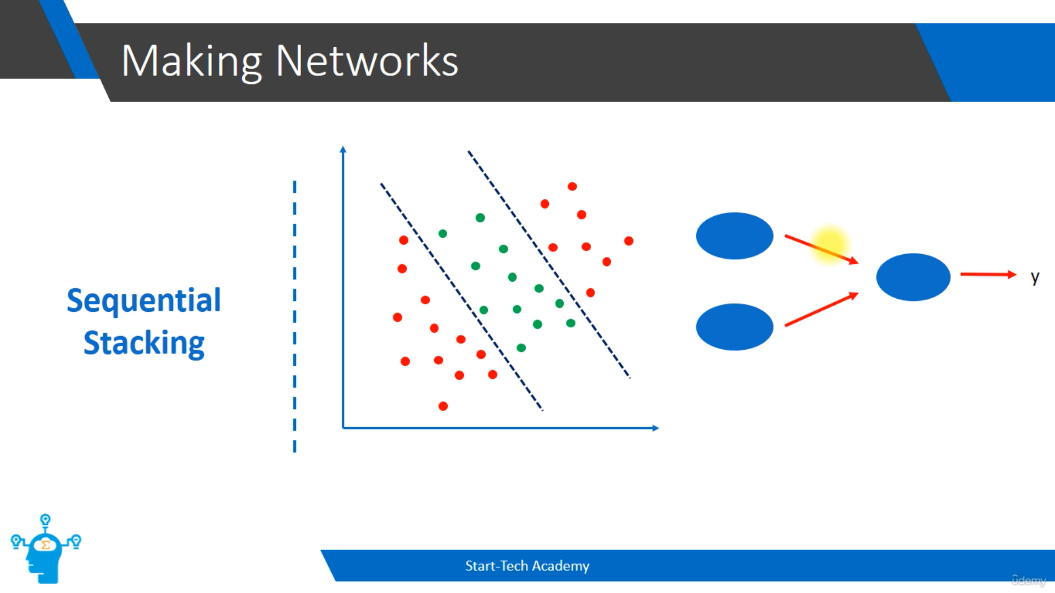
3rd neuron

2nd neuron

1st neuron

The first neuron will give one as output if it lies left of the first line and the second neuron will give one as output if it lies of the right of the second line and the third neuron will give one if any one of the neuron gives one as output.
Each neuron can focus on the particular features of the object instead of the final outcome.
